**Johnston Community School**

**Child Friendly Online Safety Policy**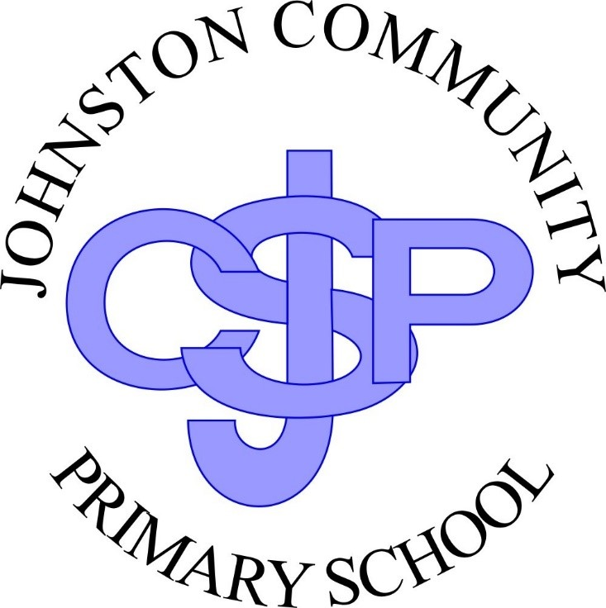

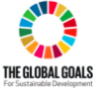

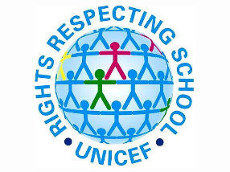

March 2022

Reviewed by Governing Body

Johnton School is a **Rights Respecting School.** We put the United Nations Convention on the Rights of the Child (**UNCRC**) at the heart of our school’s planning, policies, practice and ethos.

**Article 1:** Everyone under 18 has these rights.

**Article 2:** All children have these rights no matter what.

**Article 3**: Everyone who works with children should always do what is best for each child.

**Article 12**: Your right to say what you think should happen and be listened to.

**Article 13**: Your right to have information.

**Article 17** Your right to reliable information from a variety of sources, and governments should encourage the media to provide information that children can understand. Governments must help protect children from materials that could harm them

**Article 28**: Your right to learn and go to school.

**Article 29**: Your right to become the best you that you can be.







