
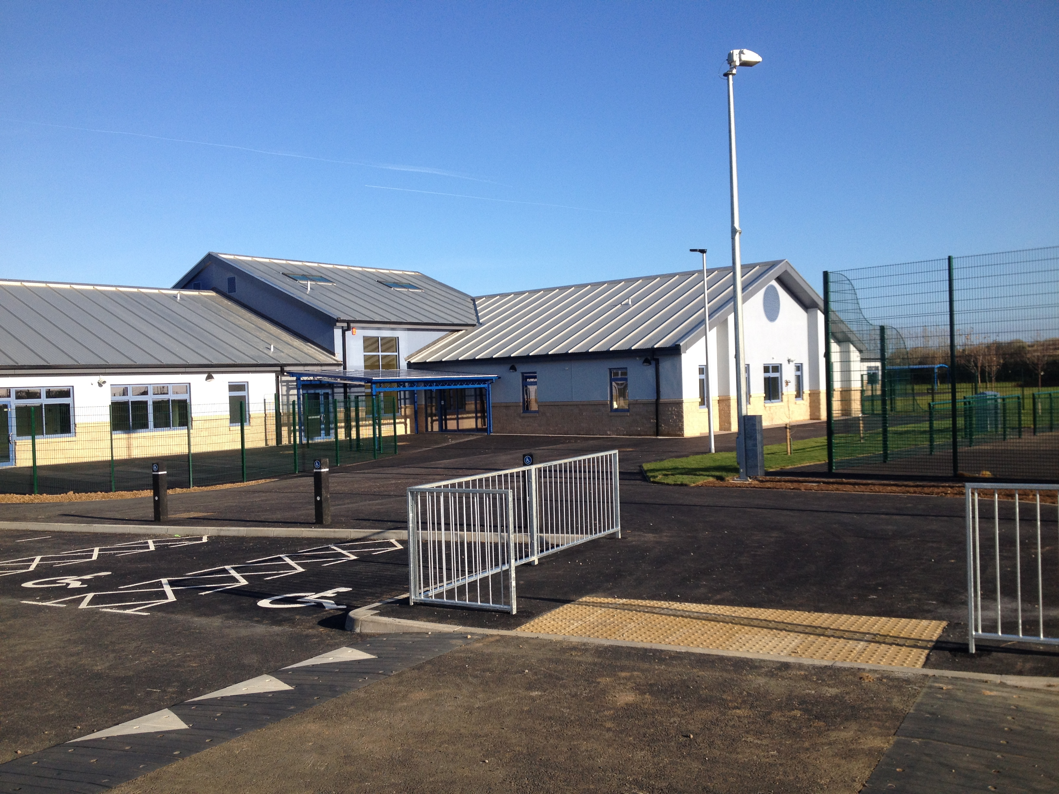

POLICY DOCUMENT FOR SEESAW

Tel: 01437 890280
Fax: 01437 890280
Email: admin.johnston@pembrokeshire.gov.uk

Trial March 2017

Purpose
Johnston C.P. School is trialling the use of the Seesaw App to celebrate pupils’ work and share that work with the parents of the pupils in Dosbarth Pili-Pala. Parents are invited to comment on their child’s work as a positive home-school link. Seesaw will not be used to share personal, medical or confidential information.

Data

The data we upload is used to celebrate the pupil’s achievements, and will include photos, videos, video stories, work, drawings, voice recordings and other digital content created by the pupils or Johnston staff. This data is linked to the pupil’s Seesaw account.

Data Storage

- Seesaw takes protecting your security and privacy seriously and have put a number of measures in place to protect the integrity of the account.

- Seesaw never sell or share any account information or journal content with 3rd parties.

- Seesaw uses SSL security at the network level to ensure all account information and journal content is transmitted securely.

- Account information is stored in highly secure, access-controlled data centres operated by industry leading partners with years of experience in large-scale data centres. This may be stored in the E.U. or the U.S.

- Teachers are always in full control over journal content, and have the opportunity to approve new journal items.

- Seesaw have adopted an internal data access policy that restricts access to personally identifiable information to a limited number of employees with a specific business need (such as for technical support).

- Seesaw routinely monitor systems for security breaches and attempts at inappropriate access.

- Use of encrypted QR codes for parent & student access to journal content.

Seesaw links

Seesaw Privacy Policy https://app.seesaw.me/about/privacy

Data storage http://help.seesaw.me/hc/en-us/articles/204472519-Where-is-my-data-stored-

Acceptable User Policy

Johnston C.P. School are trialling the use of Seesaw this term. This is a secure online learning journal to upload children’s work, photos and videos to document their learning, to share and celebrate their achievements with you (the parent/carer).

Your child, teacher or school support staff will add media such as photos, videos, video stories, classwork, drawings, voice recordings and other digitally created media to their Seesaw journal.

The Seesaw Parent account notifies you when new content is added, allowing you instant access to their journal. Seesaw journals are private and only accessible by the teacher, students, and parents.

Because of the nature of the service, Seesaw collects personally identifiable information, like your child’s first name, and uploaded content. Seesaw has a robust privacy policy (https://app.seesaw.me/about/privacy) and has committed to never share your child’s personal information or journal content.

We hope that you and your child will enjoy using Seesaw to document, share and celebrate their learning.

Please sign below:

I give consent for my child, ____________________________ to have a Seesaw account that is to be used for class activities and sharing and celebrating their achievements.

I agree that I will only write comments about my child’s achievements and learning on the Seesaw Parent account.

Parent/Carer Printed Name: __________________________________

Parent/Carer Signature: __________________________________

Date: _________________

