**Johnston Community Primary School**  **Substance Use and Misuse Policy**

The United Nations Convention on the Rights of the Child (CRC) is at the heart of our school’s planning, policies, practice and ethos. As a rights-respecting school we not only teach about children’s rights but also model rights and respect in all relationships – Linked to Articles 6, 33, 36 (CRC)

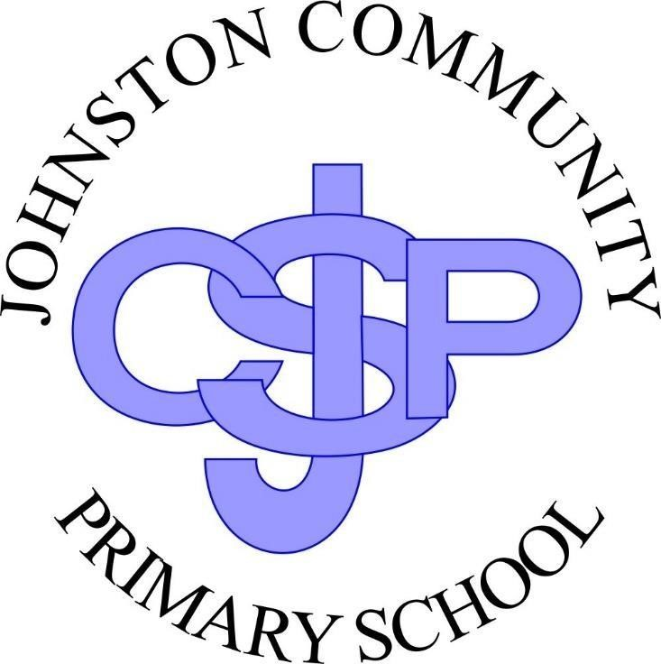

|  |  |
| --- | --- |
| Policy first approved on: | Spring 2022 |
| **Policy to be reviewed:** | Spring 2024 |
| **Last Review Date** |  |
| **Member of staff responsible for this policy:**    **Governor** |  |

# 1. Rationale

The Welsh Government’s (WG) 10-year strategy, *Working Together to Reduce Harm*, establishes the parameters of how substance misuse can be addressed. The preventing harm priority action area within this strategy aims to help children, young people and adults resist or reduce substance misuse by providing education about the damage that substance misuse can cause to their health, their families and the wider community. This includes delaying the age that children and young people start drinking. It also includes action to identify people at risk of substance misuse and/or in need of support and signposting to further information, support or diversion activities.

We are part of Pembrokeshire’s Healthy Schools Scheme and recognise the value of taking a whole school approach to substance misuse education (SME) which includes the curriculum, school environment, ethos, leadership and community links.

# 2. Definition of a Substance

The standard definition of a drug or substance used for this policy is - *‘A substance is something people take to change the way they feel, think or behave’* (United Nations).

A defined range of the substances covered by this policy include:

* tobacco and e-cigarettes
* alcohol
* over the counter medicines
* prescription only medicines such as anabolic steroids and benzodiazepines
* illegal substances such as heroin, cocaine, ecstasy, amphetamines, LSD, cannabis, magic mushrooms
* volatile substances such as aerosol propellants, butane, solvents and glues
* new psychoactive substances (previously known as ‘legal highs’)

Many drugs are lawfully carried as medicines. There is a clear policy on the administration of medicines, however, if pupils supply prescription drugs to others in school, they are acting unlawfully and therefore this policy will apply.

# 3. Aim

Schools play an important role in having a positive and sustained impact on children and young people’s health and well being. Effective substance misuse education provides learning opportunities for children and young people to acquire the skills, knowledge and understanding to make informed choices about substance misuse. We aim to be sensitive and respect differences whilst enabling pupils to understand the risks associated with substance use and misuse. This policy will provide clear guidance about how Johnston School will respond to incidents of substance misuse, balancing the need for sanction with support. Engagement with the school community is the key to promoting a positive and consistent message about substance misuse issues and Johnston School would welcome any comments from all our parents and carers.

# 4. Objectives

* To actively participate in the Pembrokeshire Healthy Schools Scheme and ensure Johnston School is a smoke free environment and to actively promote ASH Cymru’s smoke free and vape free school gates campaign. This includes e-cigarettes, e-cigs or ENDS (electronic nicotine delivery systems).

* To ensure contractors / organisations / individuals using, visiting or working on school premises agree to comply with the Substance Misuse Policy and ensure the site remains smoke and substance free.

* To ensure the school does not permit smoking in any part of the premises, entrances or grounds at any time, by any person regardless of their status or business with the school. This policy extends to the use of the building outside school hours. Our school conforms with the new Smoke Free School Site legislation. Please refer to our Smoke Free School Site Policy.

* To increase pupils’ knowledge and understanding of substance misuse.

* To challenge attitudes and highlight social norms relating to substance misuse.

* To help pupils develop skills to help them deal with challenges of substance misuse throughout their life.

* To provide consistent messages about substance misuse within and outside of the taught curriculum.

* To manage substance related incidents with due regard for our legal obligations and the need for support as well as sanction.

* Support Staff and Parents who want to quit smoking or the use of other substances by ensuring relevant information is available / displayed on schools site, for example,

Stop Smoking Wales Helpline 0800 085 2219 / [www.stopsmokingwales.com](http://www.stopsmokingwales.com/) displayed in staff room and school website. Please visit our school website: [Substances/Sylweddau - Jo](https://www.pembreyprimary.org.uk/substancessylweddau/)hnston School

Johnstoncommunityprimaryschool.co.uk

* Raise awareness among parents and share information as appropriate e.g. National No Smoking Day, Alcohol Awareness Week etc.

# 5. Consultation and Implementation

This policy has been developed in consultation with representatives of the groups the policy will affect. This includes: • *Children and young people*

* *Staff*
* *Parents/carers*
* *Governors/management committees*
* *Partner organisations & wider community*

The Head teacher and Governing Body have ultimate responsibility for the implementation of the Substance Misuse Policy and management of incidents or disciplinary procedures.

At Johnston School the member of staff with responsibility for coordinating this substance misuse policy and its implementation is Mr. Ross Williams.

The school Governors will review this policy in line with the review policy cycle. Governors may also be involved in disciplinary proceedings as and when required.

This policy should be considered in conjunction with other related policies and procedures including:

* Personal and social education (PSE)
* Behaviour management
* Anti-Bullying
* Equal opportunities
* Arrangements for reporting absence and keeping confidential records
* Extra- curricular activities including residential excursions
* Safeguarding and child protection procedures • Inclusion
* Health & safety
* Medicines management and administration
* Smoke Free School Site Policy.

# 6. Delivery of Substance Misuse Education / Curriculum

Effective SME should start early and be age appropriate. Effective SME aims to empower children and young people to make responsible, well-informed decisions about substances used and/or misused within society. Substance misuse education is more effective when it is underpinned by a whole-school approach which adopts a positive school ethos and supportive policy. The school curriculum in Wales provides clear opportunities for learners to acquire the skills, knowledge and understanding they need to make informed choices when they encounter illegal drugs and legal substances.

Through our current PSE curriculum and the Health & Well-being AOLE, our Foundation Phase pupils are provided with opportunities to:

* *Develop an understanding about dangers in the home & outside environment*
* *Understand that there are ‘good’ and ‘bad’ substances with medicines being classed as a ‘good’ substance that can make you feel better, whilst other substances are dangerous.*

Our Key Stage 2 Pupils are provided with opportunities to:

* *identify links between cause and effect*
* *distinguish between facts, beliefs & opinions*
* *form personal opinions and make informed choices*
* *understand that decision making in relation to substances can impact on the quality of their lives & that of others*
* *understand what peer pressure is and how to withstand / resist it*
* *understand the harmful effects to both themselves & that of others including long term effects of tobacco, alcohol, legal & illegal substances - learn the correct terminology given to a variety of substances*

All of our pupils are also educated about the ‘Don’t Touch-Tell’ practice in relation to touching or consuming discarded substances or injecting needles. Pupils are instructed not to touch any substances they may find within the local area and to inform a trusted adult or the police.

Our local School Police Liaison Officer, PC Adam Thomas, contributes to our Schools Substance Misuse Education Curriculum as part of the All Wales School Police Liaison Programme. There is a specific Lesson Matrix that Pc Adam must deliver at our school. The following lessons from the Matrix contribute to our schools Substance Misuse Education Curriculum:

**Foundation Phase (FP); *Who? What? Where?***

**Key Stage 2 (KS2): *Sinister Substances & So What’s the Problem?***

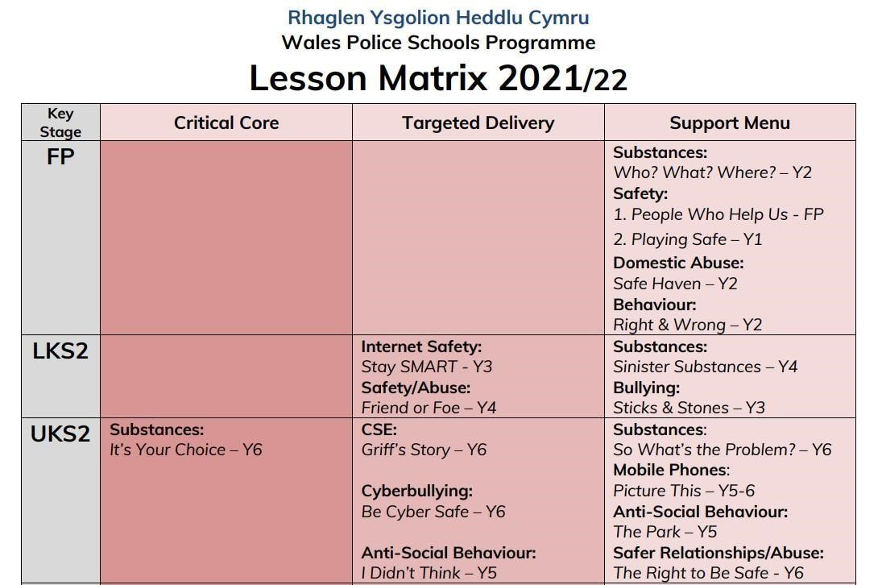

The implementation of Circle Time sessions and Jigsaw lessons across the school also contributes significantly to the development of the skills, attitudes and values that pupils require as they progress through all phases of life.

At Johnston School pupils will learn about SME using approaches that provide:

* consistent accurate information presented simply and clearly
* informative and accessible reading material
* access to peers and credible adult experts, in addition to teachers
* stimulating and enjoyable tasks
* appropriate challenges in an atmosphere, where they feel secure enough to play a full and active part

## 6.1 Use of outside Speakers

Contributions from outside speakers or theatre groups are no substitute for a properly resourced teacher led programme. However, Johnston School will welcome them to enrich the SME Curriculum if:

* The input is part of a programme and jointly planned with the teacher.
* The approach compliments that of the school programme.
* The teacher is present so they can follow up the input at a later stage. As long as the teacher is present, there is no requirement for visitors to have a police check.
* The speaker has experience and expertise in Substance education and working with young people.
* The outside speaker can offer something specific and useful that teachers cannot (such as information about helping services young people can use or knowledge about the law and the consequences of breaking the law in this area).
* Ex drug users/alcoholics should not be used – evidence strongly suggests that these people ‘glamorise’ drug/alcohol misuse and have the effect of actually encouraging children and young people to misuse.

Johnston School will give careful consideration in relation to the use of outside agencies to ensure that a positive educational message is given rather than shock horror or fear employed to change behaviour: for example, inviting in police sniffer dogs to demonstrate their efficiency in finding drugs in bags or pockets – this is a useful deterrent message providing pupils are forewarned and have the opportunity for discussion. Any other use of drugs dogs in schools may lead to serious break down of trust between school, pupils and families.

## 6.2 Guidance on Sensitive Issues

As with other sensitive subjects, teachers at Johnston school will not offer confidentiality to pupils, nor will they talk about their own personal experiences or lack of them, unless they feel comfortable doing this and it contributes to pupil’ learning or to trust between pupils and teacher. **Under no circumstances will Johnston teachers admit to having done anything illegal however long ago.**

Teachers at Johnston School will answer pupils’ questions openly and honestly giving due attention to the maturity and understanding of the pupils concerned. Information arising from discussions cannot be regarded as confidential as teachers may have to act to protect pupils from harm by involving or informing other adults such as parents or the police.

# 7. Training

The Senior Management Team (SMT) will ensure that there is adequate training and resources for all staff involved in the delivery of the aims and objectives of the Substance Misuse Policy. Training for staff should be provided to build knowledge, skills and confidence. All staff are present during sessions / lessons delivered by Outside Speakers or Key Partners such as PC Adam and will therefore retain the latest information shared and reiterate as and when needed to pupils.

# 8. Complaints Procedure

Any complaints about Substance Misuse Education will be made to the SMT who will report to the Governors.

# 9. Media Contact

Staff at Johnston School will not report incidents and/or issues concerning Substance Misuse to the local press and media generally. The Head teacher, in consultation with the LEA and Governors will deal personally with all media matters.

**10. Procedures for dealing with an incident**

The types of substance misuse related incidents will vary. Johnston School is prepared for these possibilities and has a range of responses that are considered appropriate.

Staff who become aware of difficulties and/or incidents involving pupils and substances will inform the responsible staff member, named in section five of this policy. The response will depend on the type and degree of risk, with some situations requiring immediate action referring to the Schools Management of Emergencies policy, procedures and guidance’ document.

**Immediate action is needed when there is a clear risk to safety, for example:**

|  |  |
| --- | --- |
| **Example** | **Action** |
| *An adult collecting a child or young person appears to be under the influence of drink and/or drugs* | **Apply locally agreed child protection procedures, involve the police if adult is aggressive** |
| *A child or young person/adult appears ill or unsafe as a result of substance misuse* | **Obtain medical advice, note relevant facts and inform parent/carer** |
| *Substances are being supplied on, or near premises* | **Contact School Community Police**  **Officers** |
| *There is ready access to controlled drugs* | **Contact School Community Police**  **Officers** |
| *The school has potentially hazardous substance misuse related litter e.g. needles, syringes* | **Arrange safe removal of litter according to health and safety policy**  **Review school risk assessment in accordance with required standards of control**  **Involve police if related to illegal substance misuse** |
| *A child/young person discloses that they are misusing drugs or their parent/carer or other family members are misusing drugs* | **Contact social services or specialist substance misuse service for advice on how to respond** |

**Less immediate action, e.g. observation, interview, consultation with other agencies, continued monitoring, may be appropriate when there are, for example:**

* generalised allegations or concerns about a particular pupil or family
* refuted/inconsistent disclosures
* concerns but no evidence of substance misuse or related harmful or criminal conduct (such as supply of drugs or other harmful substances) • concerns but no evidence of immediate risk to safety.

**Actions requiring referral to other organisations include:**

* Investigation of criminal activity, including searching persons or personal property.

School Crime Beat Protocol provides guidance for taking action in line with police policy.

* Apart from immediate first aid, any health or medical emergency which should be attended by appropriate medical personnel.
* Assessment and providing support and services to vulnerable or troubled children and families are matters for social services.
* Counselling and drug treatment programmes require trained staff, normally accessible through social services, health or specialist substance misuse services.

# 11. Contact with Parents

Parents will be informed of any substance related incident unless:

* There are child protection concerns
* It would interfere with a school investigation
* It would interfere with a police investigation
* It could result in greater harm to the child for another reason

Pupils will be invited to turn out their pockets but only the police have the power to search pupils. There will be a reasonable attempt to contact parents to inform them that a search will take place.

# 12. Contact with Police

There are three main levels of response that the Police can provide when responding to incidents of substance misuse:

1. Collection, transfer and disposal of any suspected substances 2. Partnership investigation

3. Formal police investigation

For **ALL** substance misuse incidents, the school will involve the School Community Police Officer and not the emergency police. If they are not available and if the situation is an emergency, then a 999 call may be necessary for a quicker response.

# 13. Procedure for dealing with a pupil after an Incident

Staff who become aware of difficulties and/or incidents involving pupils and substances will inform the head teacher.

The response will depend on the type and degree of risk, with some situations requiring immediate action and others requiring time for assessment of information, seeking advice and the involvement of other agencies. In all cases the safety and security of pupils is a priority. Some responses may include:

* specialist support or treatment provided by outside agencies
* school based counselling services
* restorative approaches
* youth support services
* behaviour contracts

If a pupil is at risk because of impaired mental state, parents should be contacted and required to take control of their child. Failing that, any emergency contact will be asked to assist. Alternatively, social services and police can be called for advice.

## 13.1 Recording of Incidences

At Johnston School the system for recording an incident will include accurate factual records of all substance misuse and related incidents using:

• Incident Recording Form provided in the Guidance for substance misuse education document 107/2013 *(Please see Annex G)*

The record of the incident and interview will be signed and dated by the responsible member of staff, Police, including at least one witness. Records will be completed as soon as possible after the incident. The governing body will monitor substance misuse incidents.

## 13.2 Out of School Procedures

The school has no role in dealing with drug incidents outside school hours and premises other than:

* On school trips and visits, when the same rules and procedures will be applied as far as is reasonable and practicable.
* By passing information onto relevant agencies when the safety or well being of a pupil is threatened.
* To assist police in preventing the use of land surrounding the school for drug trading.
* Safely removing the debris, needles, sharps from site accordingly.

# 14. Safeguarding & Confidentiality

An important aspect of a confidential conversation is to agree what will happen to the information disclosed however, teachers will not promise confidentiality. The boundaries of confidentiality will be made clear to pupils. It may be necessary to invoke local Child Protection Procedures if a pupil’s safety or welfare (or that of another pupil) is under threat. If a pupil discloses information which is sensitive, not generally known, and which the pupil asks not to be passed on, it will be discussed with a senior member of staff. Confidentiality may be breached against the wishes of the person confiding the information when necessary:

* where there is a children and young people safeguarding issue
* where the life of a person is at risk or there is risk of serious harm to others
* when criminal offences are disclosed under the Misuse of Drugs Act 1971.

Every effort will be made to secure the pupils agreement to the way in which the school intends to use any sensitive information.

# 15. Procedure for Dealing with Incidents Involving Staff

Substance misuse related incidents involving staff are subject to Pembrokeshire County

Council’s Employment and Disciplinary Policy and Procedures and are linked to the Drug and Alcohol at Work Policy. The safeguarding of children and young people is of greater urgency than staff disciplinary procedures.

# 16. Procedure for Dealing with Adults (not staff)

Johnston School will not release pupils into the care of other adults where there is a possibility of harm to that pupil. Where there is evidence that parents or carers arriving at school to collect pupils are under the influence of drugs or alcohol, Social Services or Police will be contacted in line with the Child Protection Policy.

Where a parent or visitor is/or appears to be under the influence of a substance on the school premises and they will be asked to leave immediately. The parent /visitor’s safety will be ensured, with supervision if necessary, provided this can be achieved without putting employees or others at risk of physical harm. Where illegal substances may be involved, Police will be informed.

**17. Litter disposal on school grounds**

# Needles and syringes

Discarded needles and used syringes present health and safety implications and if found on school premises the following protocol will be followed:

* The head teacher will be informed
* The paraphernalia will be placed in a sharps box, using protective clothing and equipment referred to in the school guidance document ‘safe handling and disposal of needles’ and in accordance with the school’s risk assessment (this will include gloves and tweezers or other implement to avoid direct handling / puncture wound).
* The local police will be contacted to empty the box (disposal contacts are to be found in the above school guidance document)
* Inform the School Community Police Officer
* Substance misuse incident recording form will be completed • Education with pupils

# Substances or substance related paraphernalia

Where a suspected substance is found or recovered within the confines of a school, the Police School Crime Beat Policy recommends the following:

* The head teacher will be informed
* If someone is in possible danger or is likely to be at risk of harm - ring 999 Ensure that the seizure is witnessed in corroboration with another member of staff

* Contact the School Community Police Officer or Neighbourhood Policing Team for disposal and advice regarding future action
* If the School Community Police Officer is not available – the local police station should be contacted. Explain the situation and ask for an incident number
* Store it in a suitable location pending police arrival
* A substance misuse incident recording form will be completed, with witness signatures
* Staff should not attempt to analyse or taste any unidentified substance
* Care must be taken with disposal of cans, bottles and broken glass • Education with pupils

## 17.1 Volatile Substances

Johnston School is responsible for the controlled use and security of Volatile Substances such as aerosol propellants, butane, solvents and glues where they are authorised for use for curriculum purposes, in accordance with relevant CLEAPSS Risk Assessments.

# 18. Equality

All pupils, their parents and guardians, volunteers, staff and school governors are valued and will be treated with dignity and respect. The school will not tolerate any form of discrimination, harassment or victimisation.

We will work across our school community to ensure our commitment to equality and fairness is shared and take steps to ensure that our school is accessible, welcoming and inclusive.

# 19. Monitoring and Evaluation

* Opportunities will be provided which will enable pupils to participate and evaluate what they have learnt according to their age, needs and ability

* Parents will be invited to feedback their ideas for improvements on a regular basis both verbally and through questionnaires

* School Council are responsible for the child friendly version of this policy

* Progress will be monitored at regular intervals by SMT and governors. Specific issues will be discussed at staff meetings as appropriate

# 20. References

*Guidance for substance misuse education* (2013) Guidance document no: 107/2013, Welsh Government

*Foundation Phase Framework for Children’s Learning for 3 to 7 Year Olds in Wales* (2008), Welsh Assembly Government

*Personal and social education framework for 7 to 19 year olds in Wales* (2008), Welsh Assembly Government

[Health and Well-being: Introduction - Hwb (gov.wales)](https://hwb.gov.wales/curriculum-for-wales/health-and-well-being/)

[Health and Well-being: Statements of what matters - Hwb (gov.wales)](https://hwb.gov.wales/curriculum-for-wales/health-and-well-being/statements-of-what-matters/)

*Tobacco Control Action Plan for Wales* (2012), Welsh Government

*Working Together to Reduce Harm: The Substance Misuse Strategy for Wales* (2008 – 2018), Welsh Assembly Government

# 21. Useful Websites

[www.schoolbeat.org](http://www.schoolbeat.org/)

[www.dan247.org.uk](http://www.dan247.org.uk/)

[www.talktofrank.com](http://www.talktofrank.com/)

[www.drugscope.org.uk](http://www.drugscope.org.uk/)

[www.drinkaware.co.uk](http://www.drinkaware.co.uk/)

[www.siedsinfo.co.uk](http://www.siedsinfo.co.uk/)

**REVIEW**

This policy is reviewed on an annual basis or sooner if legislation and LA guidance changes.

