|  |
| --- |
| **Johnston Community Primary School** |

|  |
| --- |
| **School Development Plan**  **2023-2024** |



|  |  |  |  |
| --- | --- | --- | --- |
| **Date Approved** | **September 2023** | **Date of Next Review** | **September 2023** |
| ***Signature*** | Headteacher | ***Signature*** | Chair of Governing Body |

|  |  |  |
| --- | --- | --- |
|  |  | Page No |
| **Our School** | Our School Context | 3 |
|  | Mission Statement | 3 |
|  | Aims & Objectives | 3 |
|  | General Information | 4 - 5 |
|  | Roles & Responsibilities | 6 - 8 |
|  | Available Resources & Grants | 9 |
| **Priorities and targets** | Priority Areas Summary 2023-2024 | 10 |
|  | Priority Areas 1 - 6 Action Plans | 11 - 19 |
|  | Overview of Professional Development 2023-2024 | 20 |
| **Appendices** | Monitoring Milestones timetable 2023-2024 | 21 |

**Contents**

# Context

Johnston Community Primary School moved to a new site in January 2017. The school was placed in Estyn monitoring in 2017. Since time, the school has had a considerable turnover of staff and more than fifty percent of our teachers have joined in the last three years. Johnston is situated in mid-Pembrokeshire between the large towns of Milford Have and Haverfordwest. Milford Haven has high levels of unemployment and low levels of income and as a result, is one of significant socio-economic disadvantage. Johnston has pockets of deprivation and pockets of affluence. A significant number of pupils attend from outside catchment. In some classes, as many as thirty percent of pupils have address which are not in the Johnston catchment area.

Johnston Community Primary School is an English medium school with approximately 267 pupils on roll (FTE PLASC 2023). Pupils are taught in seven mainstream classes and there are two local authority specialist classes. In recent years we have spent a significant amount of time developing our curriculum and a core part of the offer that we have developed has been outdoor learning. We are an ambitious school and we are keen to develop as a learning organisation. In recent years, we have held open days which have been attended by schools as far as Cardiff.

Very few pupils speak Welsh fluently at home. Approximately 1.5% of pupils have English as an Additional Language (EAL). Five pupils are looked after by the local authority (YPLA). Around twenty percent of pupils are entitled to free school meals (14.6 % PLASC 2023) and the school has identified around 27% of pupils as having additional learning needs, both figures are higher than the national averages.

The headteacher was appointed to the in September 2017. In September 2022 the headteacher was seconded to run another Primary school in the Local Authority. Since then, the Deputy Heateacher has acted up in his absence. As a result, the school has introduced an altered leadership structure to ensure that it continues to make progress as a learning organisation.

**Mission Statement**

Johnston Community Primary School, a forward looking school that provides a nurturing environment for all. We have a creative and engaging curriculum steeped in learning opportunities and experiences linked to real world matters, encouraging all pupils to achieve their potential in everything they do.

**School Motto: Mentra Ddysgu!**

**School Aims**

Our aims:

* To provide a stimulating, vibrant and exciting learning environment for all our children so that they feel happy and confident and are challenged to achieve excellence in everything they do.
* To treat all our children as individuals and develop their individual personalities and interests as well as developing a respect and understanding of others.
* To provide children with a sense of belonging by ensuring that Welsh and local history is a key part of our curriculum.
* To provide an inspirational modern and relevant curriculum where children develop as ambitious capable learners; ethical informed citizens; enterprising and creative contributors; healthy confident individuals.
* To provide a relevant curriculum that is irresistible, unforgettable and based on practical, real-life experiences.
* To provide a truly inclusive curriculum where difference is celebrated and children are supported and nurtured.
* To provide an environment where no child is left behind and all children can achieve their full potential both academically, physically, socially and emotionally.
* To become the heart of the Johnston Community.

​

Our School Goals:

* To ensure that children feel happy and confident.
* For children to be challenged to achieve excellence in everything that they do.
* To ensure that all children develop respect and understanding for others.
* To ensure that children have a sense of belonging and local and national identity.
* To ensure that children are ambitious capable learners; ethical informed citizens; enterprising and creative contributors; healthy confident individuals.
* All children achieve their full potential both academically, physically, socially and emotionally.
* Our children are the heart of the Johnston Community.
* For children to leave Johnston School as confident readers.

​

**Our Vision Principles**

At Johnston, we would like to ensure that we prepare children for an ever changing world of work. We believe that knowledge is important, but we don’t just focus on the knowledge curriculum. Our vision is to equip children for life by providing them with the academic, social and personal skills that they need to pursue their dreams.

A key part of our vision is to provide pupils with learning that is steeped in real-life contexts. This real world context approach to learning means pupils are provided with experiences not just lessons. They see that there is relevance and context to their learning. Much of the work that they undertake is community based too and has outcomes that positively impact upon our local community, for example, Johnston pupils have conducted a campaign to reduce the amount of plastic we use and have participated in local litter picks.

Throughout their time at Johnston, pupils' critical thinking and self-reflection skills are encouraged and developed. Pupils are taught how to critique each other's work, giving warm and cold feedback and go through a process of multiple drafting. When giving feedback to each other, children are encouraged to 'be kind, be specific, be helpful': this facilitates an academic community of learners, which ensures a constant focus on next steps and improvement.

**Leadership Structure for September 2023**

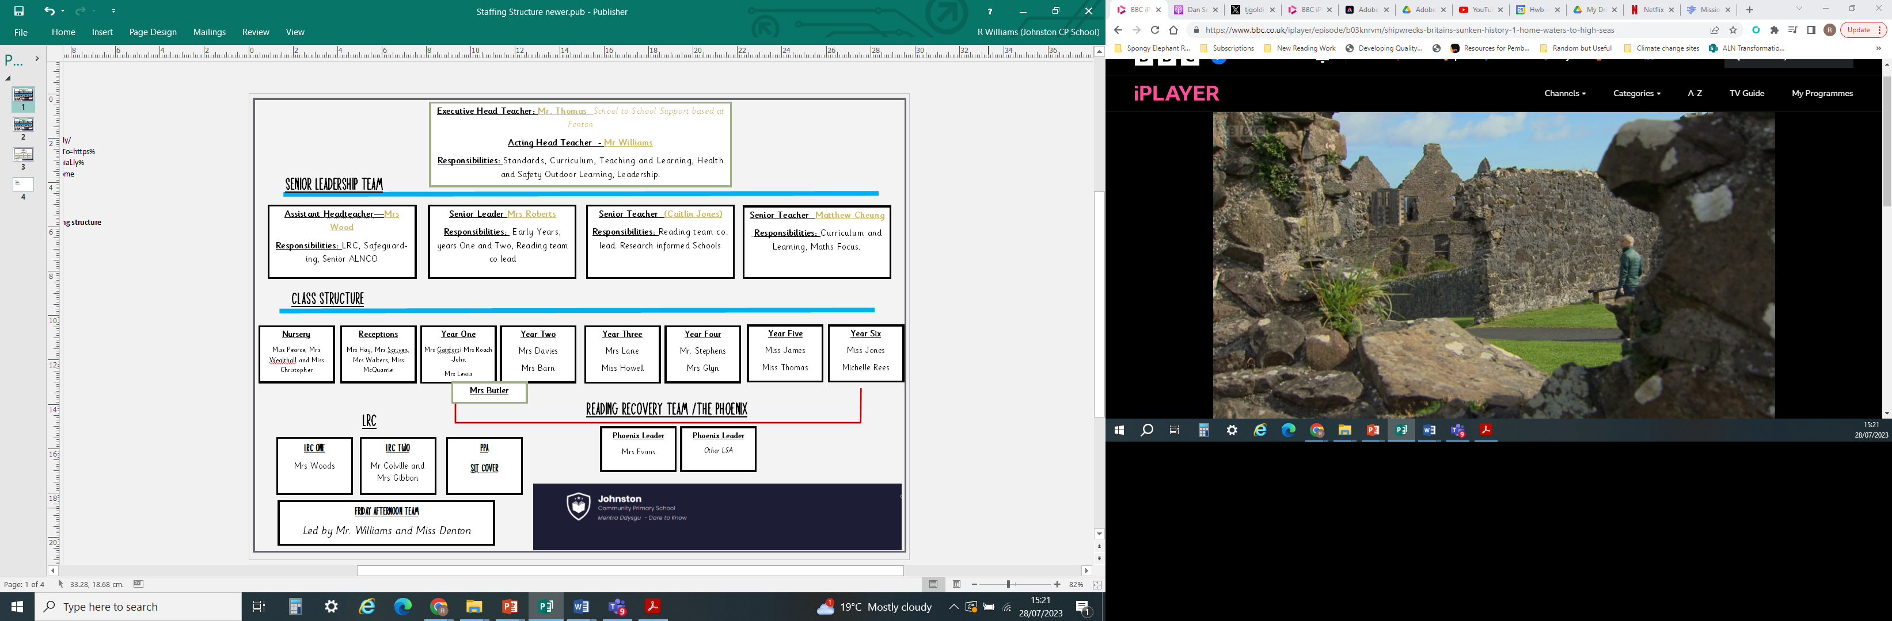

**General Information**

|  |  |  |  |  |  |  |  |
| --- | --- | --- | --- | --- | --- | --- | --- |
| Full Name of School | | WG No |  | WG Lang | Address | |  |
| Johnston Community Primary School | |  |  | EM | Langford Road, Johnston, Haverfordwest, Pembrokeshire. SA62 3PY | |  |
|  | | |  |  | | |  |
| Phone | e-mail | |  | Website | |  | Twitter |
| 01646 684872 | Williamsr1688@hwbcymru.net | |  | [www.Johnstoncommunityprimaryschool.co.uk](http://www.Johnstoncommunityprimaryschool.co.uk) | |  | @johnstonprimary |

|  |  |  |
| --- | --- | --- |
| Headteacher | Assistant Headteacher | Senior Leaders |
| (Acting) Ross Williams | Caroline Wood | Claire Roberts  Matthew Cheung  Caitlin Jones |

**Staff**

|  |  |  |  |  |  |  |  |  |  |  |  |
| --- | --- | --- | --- | --- | --- | --- | --- | --- | --- | --- | --- |
|  | Teachers | Support Staff | Admin | Site Manager | Cleaning | Lunchtime | Kitchen | Other |  | Total | |
| No. of Staff | 13 | 12 | 2 | 1 | 2 | 5 | 3 | 1 | 39 | |

**Pupils**

|  |  |  |  |  |  |  |
| --- | --- | --- | --- | --- | --- | --- |
| Speak Welsh at home | English as  Additional Lang | School Action | School Action Plus | Statement of SEN | Eligible for FSM | Looked after by local authority |
| 0% | 1.49% |  |  |  | 14.60% | 0.37% |

|  |  |  |  |  |  |
| --- | --- | --- | --- | --- | --- |
| LA IDP | School Action+Stat Assmt | School IDP | School/Early Years Action | School/Early Years Action+ | Statement |
| 3.74% | 10.48% | 0.37% | 0.74% | 5.99% | 3.37% |

**Specialist provisions**

|  |  |  |
| --- | --- | --- |
| The Phoenix Group | Nurture provisions | LRC |

|  |  |  |  |  |  |  |  |  |  |  |  |
| --- | --- | --- | --- | --- | --- | --- | --- | --- | --- | --- | --- |
| Names of classes and members of staff | | | Number of pupils | | | | | | | | |
| Class | Teachers | Support Staff | N | R | Y1 | Y2 | Y3 | Y4 | Y5 | Y6 | Total |
| EY 1 AM | Rachel Pearce | AW, JC, SM | 16 |  |  |  |  |  |  |  | 16 |
| EY 1 PM | Rachel Pearce | AW, JC, SM | 15 |  |  |  |  |  |  |  | 15 |
| EY 2 FT | Rachel Pearce | AW, JC, SM | 10 |  |  |  |  |  |  |  | 10 |
| REC | Ceris Hay | KS, SH, RW, |  | 24 |  |  |  |  |  |  | 24 |
| 1 | Rachel Roach-John (0.6), Gemma Gainfort (0.6) | KL, KB |  |  | 27 |  |  |  |  |  | 27 |
| 2 | Helen Davies | SB |  |  |  | 26 |  |  |  |  | 26 |
| 3 | Jayne Lane | NE, SJ |  |  |  |  | 23 |  |  |  | 23 |
| 4 | Adam Stephens | JG |  |  |  |  |  | 31 |  |  | 31 |
| 5 | Matthew Cheung | ET |  |  |  |  |  |  | 30 |  | 30 |
| 6 | Caitlin Jones | MR |  |  |  |  |  |  |  | 31 | 33 |
| LRC 1 | Caroline Wood | CM, AL, NW, GH, | 2 | 6 | 3 |  |  | 1 |  |  | 12 |
| LRC 2 | Catherine Gibbens (0.4)  Tom Colville (0.6) | CP, MS (0.6), JB, NS, |  |  |  | 1 | 3 | 4 | 2 | 3 | 13 |
|  |  |  |  |  |  |  |  |  |  |  |  |
| Total in each year | | | 43 | 33 | 29 | 24 | 34 | 35 | 33 | 36 | 267 |

5

## Roles and Responsibilities Sept 2023

|  |  |  |  |  |  |  |  |  |  |
| --- | --- | --- | --- | --- | --- | --- | --- | --- | --- |
| **Subject/Area** | | | | **Staff** | | | | | |
| Assistant Headteacher & ALNCO | | | | Caroline Wood | | | | | |
| Senior Leadership Team (SLT) | | | | Claire Robets, Caitlin Jones and Matthew Cheung | | | | | |
|  | Middle Leadership Team |  | | Adam Stephens, Jayne Lane, Helen Davies, Gemma Gainfort and Rachel Roach-John | | | | | |
| Safeguarding | | | | Caroline Wood, Ross Williams. | | | | | |
| Business Support and Admin | | | | Debbie Williams | | | | | |
| Welsh Second Language (WSL) Leads | | | | | | Jayne Lane | | | |
| WSL Champions | | | | Jayne Lane, Ross Williams, Aled Thomas (Governor). | | | | | |
| Trained coaches | | | Caroline Wood | | | | | | |
| Performance Management | | | | Ross Williams | | | | | |
| Professional Learning | | | | Ross Williams | | | | | |
| Research Enquiry Support | | | | Caitlin Jones | | | | | |
| Health and Safety | | | | Ross Williams, Caroline Wood | | | | | |
| Young Leaders | | | | Helen Davies | | | | | |
| School Council | | | | Ross Williams | | | | | |
| Rights Respecting Schools | | | | Cailtin Jones | | | | | |
| Empathy Lab Lead | | | | Caitlin Jones | | | | | |
|  | End of Phase assessment |  | | Ross Williams. | | | | | |
| More Able and Talented (MAT) | | | | | Matthew Cheung | | | | |
| Looked After Children (YPLA) | | | | Linda Greenish | | | | | |
| English as an additional language (EAL) | | | | | | | Caroline Wood | | |
| Young Carers | | | | Ross Williams | | | | | |
| Service Children | | | | Linda Greenish | | | | | |
| Family & Community Engagement (FACE) | | | | | | | | Ross Williams and Linda Greenish | |
| ESDGC/Eco Schools | | | | Rachel Roach-John | | | | | |
| Religious Education | | | | Claire Roberts | | | | | |
| Music | | | | Jayne Lane | | | | | |
| PE | | | | Tom Colville | | | | | |
| Breakfast Club, After School Club & Midday Supervisors | | | | | | | | | Ross Williams |
| Friends of the School | | | | Ross Williams | | | | | |
| First Aid at work | | | | Linda Greenish | | | | | |
| Health Care Plans | | | | Caroline Wood | | | | | |
| Library | | | | Ross Williams | | | | | |
| JRSOs/ Bike It, Sustrans | | | | Ross Williams. | | | | | |

**AOLE**

|  |  |  |
| --- | --- | --- |
|  | **Teacher Link** | **Governor** |
| **LLC** | **Jayne Lane/Caitlin Jones/Claire Roberts** | **Cllr. Aled Thomas** |
| **Maths** | **Matthew Cheung/Ceris Hay** | **Bronwyn Evans** |
| **Health and Wellbeing** | **Caroline Wood/Gemma Gainfort/Rachel Roach-John** | **Stephen Smedley** |
| **Science and Technology** | **Adam Stephens** | **Kim Scriven** |
| **Humanities** | **Helen Davies** | **Kirsty Coaker** |
| **Expressive Arts** | **Cath Gibbens** | **Sonja Groves** |
| **Attendance** | **Linda Greenish** | **Helen Davies** |
| **Curriculum for Wales** | **Ross Williams** |  |

|  |  |  |  |  |  |  |  |  |  |  |
| --- | --- | --- | --- | --- | --- | --- | --- | --- | --- | --- |
| **Governing Body Dates – 2023-2024** | | | | | | | | | | |
| **October 2023** | Finance and Staffing Meeting (Teachers Pay Review) | | | | | | | | | |
| **Oct 2023** | Health and Safety committee meeting | | | Learning Walk and Meeting Staff | | | | | Standards and curriculum meeting | |
| **Nov 2023** | Full GB Meeting October 18th 2023 | | | | | Wellbeing and attendance committee | | | | |
| **Dec 2023** | Finance and Staffing | | | | | | | | | |
| **Jan 2024** |  | | | | | | | | | |
| **Feb 2024** | Lesson Study and Listening to Learners | | | Wellbeing and attendance committee | | | | Finance and Staffing | | |
| **March 2024** | Finance and staffing | Fully Governing body | | | Standards and Curriculum | | | | | |
| **April 2024** |  | | | | | | | | | |
| **May 2024** | Wellbeing and attendance committee | | Finance meeting (SL.A. Review) | | | | | | | |
| **June 2024** | Standards and curriculum meeting | | Learning Walk and Listening to Learners | | | | | | Fully G.B. Meeting | |
| **July 2024** | Finance and Staffing | | | | | | | | | |
| **Governing Body and Link Committees** | | | | | | | | | | |
| **Finance and Staffing/Pay Review**  **1.** Miss Nicola Lewis  **2.** Mr. Ken Rowlands  **3.** Mr. Smedley | **Standards and Curriculum**  **1.** | **Wellbeing and Attendance**  **1.** Mrs. Helen Davies  **2.** Mr. Smedley  **3.** Mr. Ken Rowlands | | | | | **Health and Safety**  **1.** Mrs Kim Scriven  **2.** Mrs Tracey Young  **3.** Miss Nicola Lewis | | **HT Performance Management**  **1**. Mrs Tracey Young  2. Cllr. Aled Thomas  **3.** | |
| **Committees to be Convened as necessary** | | | | | | | | | | |
| **Complaints**  **1.** Mrs Tracey Young  **3.** Mr. Ken Rowlands | **Grievance Appeals**  **1.** Mrs Tracey Young  **2.** Mr. Chris Oliver  **3.** Mr. Ken Rowlands | **Pupil Discipline and Exclusions**  **1.** Mrs Tracey Young  **2.** Mr. Chris Oliver  **3.** Mr. Ken Rowlands | | | | | **Staff Disciplinary and Dismissal**  **1.** Mrs Tracey Young  **2.** Mr. Chris Oliver  **3.** Mr. Ken Rowlands | | **Staff Disciplinary and Dismissal Appeals**  **1.** Mrs Tracey Young  **2.** Mr. Ken Rowlands | **Link Structures**  **1.**  **2.**  **3.** |

**Pupil Voice Groups**

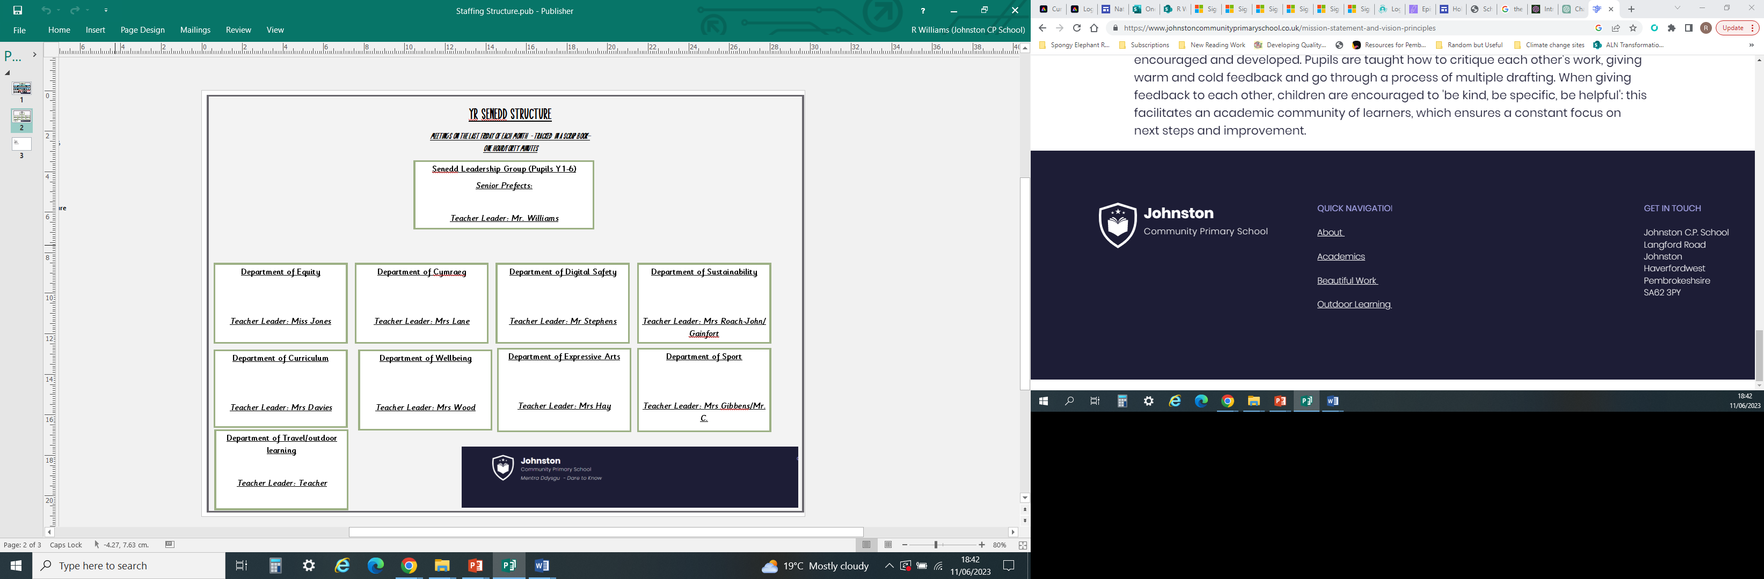

## Available Resources & Grants 2023-2024

## Additional Grants

|  |  |  |
| --- | --- | --- |
| **Grant** | **Purpose** | **Sum** |
| Regional Consortia Schools Improvement Grant (RCSIG) | Ensure each pupil profits from excellent teaching and learning, focusing on   * Improving Literacy * Improving Numeracy * Breaking the link between disadvantage and educational attainment | £15,000 |
| Pupil Development Grant (PDG) | Breaking the link between disadvantage and educational attainment | EY PDG £11,500  PDG 40,250 |

**Please refer to PDG, RCSIG and RRRS spending plans in conjunction with the SDP where costs are further broken down.**

## Our Immediate Priorities - Summary

|  |  |
| --- | --- |
| **1** | **Further raise standards in teaching and learning**  Focus on Pace, Questioning and Independence |
| **2** | **Further raise standards in teaching and learning**  Focus on Retrieval Practice |
| **3** | **Further develop the daily Welsh skills of all staff and learners (On going target)**  • Maintain and build on pupil use of daily Welsh across the school, embedding the new Welsh continuum. |
| **4** | **Further raise standards in teaching and learning**  **Literacy (Reading)**   * Continue to raise standards in reading – everyone a reader by the end of Year 2. Embedding reciprocal reading strategies. * Continue to develop BAME Reading Curriculum, including implementation of whole class sets. * Continue to raise standards in reading across the curriculum.   **Literacy (Writing)**   * Produce a detailed review of the quality of talk for writing across the school. * Improve standards of writing across the curriculum. * Ensure that we are applying new curriculum approaches to the teaching of writing.   **LRC**  Address identified areas to improve in the LRC; raising the level of challenge and pupil engagement in learning |
| **5** | **Further raise standards in teaching and learning**  **Maths**  *Sustain standards in numeracy.*  Introduce new curriculum planning.  Develop systems for Progression and Assessment.  **Reasoning**   * Introduce systems for measuring progress in reasoning. * Improve opportunities to develop reasoning across the curriculum. |
| **6** | **(Pupil Voice Target) Continued focus of high levels of well-being across the school community**   * Further develop opportunities for non-competitive sport for all pupils. * Become the first ‘Parkrun School’ in the country. |